**Final Project Cloud Engineer - DigitalSkola**

**1. Git Repository**

🔗 https://github.com/gndhmwn/final-project-digitalskola)

**2. CI/CD Pipeline**

https://github.com/gndhmwn/final-project-digitalskola/blob/main/Jenkinsfile

**3. Deployed Application**

https://final-project.ninja-sawit.tech/?name=Ganda+Himawan&security_code=nikah2025

1. **Monitoring System**

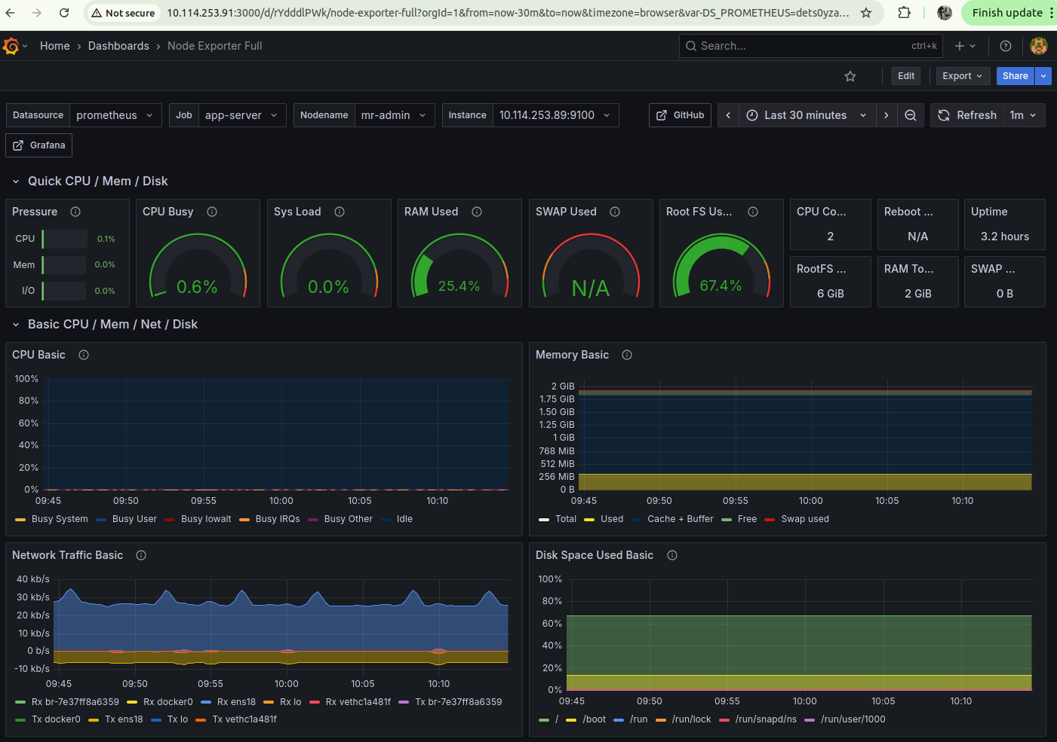

Gambar 1: Performance Metrics

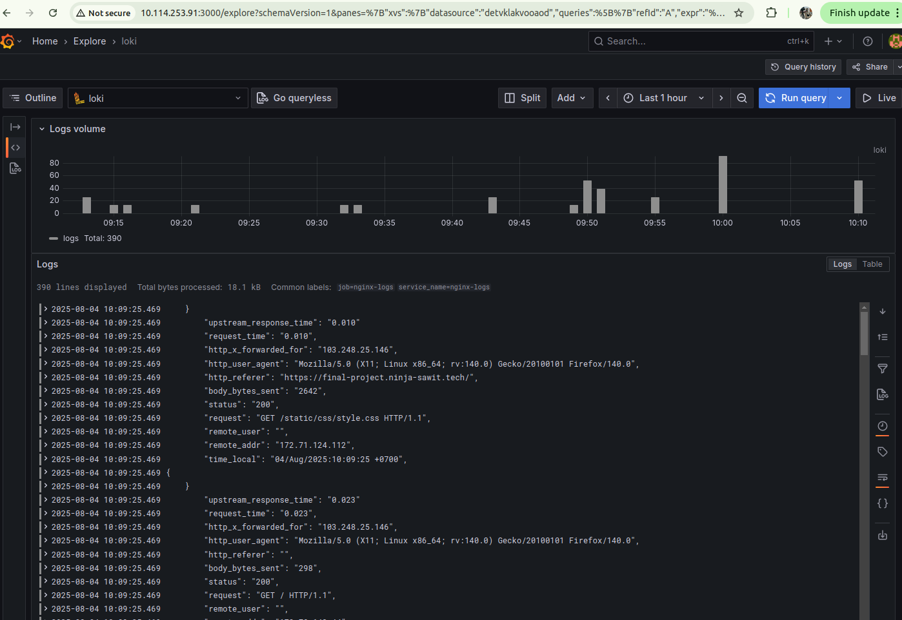

Gambar 2: Http Log

**5. Manual Scaling**

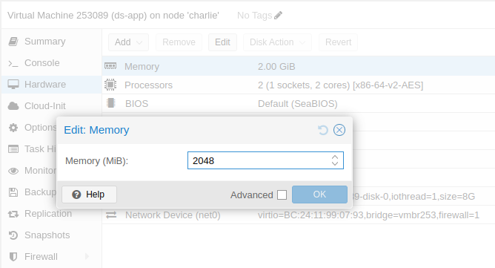

**6. Security**

